zoo

Haramaya University

College of Business and Economics

Depurtmcnt Of Economics

Macroeconomics assignment for Management DEP students, Murch 30, 2023

Prepared by: Mr. Frezer T.

Instruction:

Submission: During the final exam date

Read and answer the question carefully

# PART A: Multiple-Choice Questions

l , Studying macroeconomics is to answer the following questions; except

1. Why have some countries experienced rapid economic growth over tirne while others stay mired in poverty?
2. Why do some countries have high rates of inflation while others mamtaun stable prices?
3. Why do all countries expcnence recessions and depressions?
4. How does a consumer maximize Its utility?
5. Which of the following is/are true about classical and neo-classical school
   1. They were supporter of government Intervention to regulate the economy
   2. The neo-classical economists follow an objective method while the classical follow subjective methods of analysis
   3. The neo-classical econonusts are humanist while the classical emphasize on wealth
   4. Neo-classical supports government regulation whereas classical does not supports government intervention 10 regulate the economy
6. Which of the following policies will most likely lead to a reduction the rate of unemployment?

 Providing more job-training programs to help the less skilled

Increasing the duration of unemployment compensation

Increasing government purchases of goods and services

Raising the minimum wage

Increasing the money supply

1. Why the short run nggtcgllle supply upward sloping?

0. Contrnct nurke some wnge and price "sticky"

* + - 1. Firnts are often slow 10 adjust wage
      2. Menu costs make some price sticky
      3. None of the obove

1. An increase in national saving will cause the real interest rate and investment spending. to change In which or the following ways?

 Real Interest Rate Investment

|  |  |  |
| --- | --- | --- |
| a. | Increase | Increase |
| b. | Increase | Decrease |
| c. | Increase | Not change |
| d. | Decrease | Increase |
|  | Decrease | Not change |

1. According to the IS-LM model, what happen if he central bank decrease the money supply

|  |  |
| --- | --- |
| a. Increase interest rate | d. Increase Investment |
| b. Deerease income | e. None oClhe above |

c. Decrease consumption

1. According to the IS-LM model, what would not happen if government increase m taxes
   * 1. Decrease the income level c. Decrease the investment level
     2. Increase the consumption level All of the above
2. According to the IS-LM model, what happens to the national income if the government increases government purchases and taxes by equal amounts?

a. Increase

Decrease

c. Do not have effect  Indeterminate

1. Which one of the followjng is an Instrument of macrocconomics?

|  |  |
| --- | --- |
| a. Price stability | ew Change in money supply |
| b. Economic growth  10. GDP of a country does the following, except | d, Exchange rate stability |
| a. reflect the vnlue of all goods and | c. adds together clifTerent products |
| services | into a Single value |
| b. include net income inflow | d. uses murkct prices |

I l. From the phases of business cycle which one shows maximum level ofemployment and output?

1. Trough e. Boom
2. Recession d.Recovery
3. Which one is correct about approaches to measure GDP
   1. Expenditure approach gives the most value of GDP than Income and value- added approach b, Expenditure, income and value added approach result the same value of GDP

c. Income approach gives the most value or GDP than expenditure and value- added approach d. Value- added approach gives the most value of GDP than expenditure and income approach

1. A decrease in the money suply is most likely to
   1. raise interest rates and investment, and lower agregate expenditure
   2. lower interest rates, investment and aggngate expenditure c, ranse interest rates, lower Investment, and lower aggregate expenditure

d. raise interest rates, investment and aggrigate expenditure

1. One of the following is not a motive for the emergency of ADAS model,
   1. becouse IS-LM fail to entertain the supply scock
   2. beouse of IS-LM assumtions about fixed price
   3. becouse IS-LM is highly agregated in nature
   4. none of the above

15, Business cycle theory. which states changes in aggregate spending is the cause ofvananons in real GDP ofan economy, is known as:

|  |  |
| --- | --- |
| a. The monetarist theory | c. The Keynesinn theory |
| b. Rational expectation theory | d. Real Business Cycle theory |

Discussion and workout

l. There have been two main Intellectual traditions in macroeconomics. One school ofthought believes that government intervention can significantly Improve the operation of the economy; the other believes that markets work best if left to themselves. What is your opinion? Discuss your justifications.

 2. The followtng data characterize the economy of a given country (all the figures are expressed in billions ofETB):

|  |  |
| --- | --- |
| GDP at market prices | 5500 |
| Depreciation | 280 |
| Indirect taxes | 610 |
| Subsidies to firms | 20 |
| Net factor income from abroad | -150 |

Calculate:

1. GNP at market prices
2. NDP at market prices
3. NNP at market prices
4. GDP at factor prices

E, GNP at factor prices

1. NNP at factor prices
2. National Income
3. If the saving function for a county is S = -10000 + 0.8 Y, answer the following questions:

A. Derive the consumption function

B, Interpret the saving and consumption function



1. Given the consumption function 200 + 0.75 (Y-T), the investment function 200 Government purchases and taxes are both 100.

a, For the above given economy, graph the IS curve for r ranging frotn 0 to g.

* 1. Given the economy demand function Y— 100% the money supply M is 1.000 and the price level P is 2. For this economy, graph the LM curve for r ranging from O to 8
  2. Find the equilibrium interest rate and the equilibriunl level of income Y,



College of Business and Economics

Department of Management

Individual Assignment 30%

Course title: Principle of Marketing

Prepared by: Kaba Garoma

# General instructions

The assignment will be done alone.

1. Il is totally forbidden to copy from others,
2. References, citations, and intake are essential.

4, Use Times New Roman and 12 font sizes when using a computer.

5. Page numbers should be included in your assignments.

# Ouestions

li Explore the Organization's Current Marketing Activity, the existing gap and your recommendation and suggestion.

1. Enumerate advantages and possible advantages of conventional marketing channels and vertical marketing systems.
2. It is usually asserted that lirms must first assess the extent of price sensitivity to their segment before making a pricing decision. Based on this context; A. Define the concept of price sensitivity.

B. What l'actors dictate a market segment to be low price sensitive? Enumerate and explain at least four factors.

1. Marketing is managing profitable customer relationship. Discuss the concepts of customer value and how it relates to successful marketing.
2. Briefly discuss the difference between the marketing concept and the production, product, and selling concepts.

'2k L3b

# IIAR.AMAYA 1 NIVERSITY

## COLI FCF OF 'Bt SINE-SS AND ECONOMICS

OF ENT

### STATISTICS FOR M 11 INDIVIDUL ASIGNEMNT

Weight 50 %

Program DEP

L A random sample of size n = 100 is selected from a population with p = 0.60.

(a) What is the probability that the sample proportion P will be within 0.02 ol' the population proportion? That is. what is p (0.58 f P 0.62)?

2. A quality control inspector is always on the lookout for substandard parts and components provided her manufacturing company by outside suppliers. Because most ship•nenls contain some defective items. each must he subjected to inspection. Naturally, some shipments contain more defectives than others, and it is the job of the inspector to identify the most defective-laden shipments so that they can be returned to the supplier. Suppose the inspector selects a sample of n 100 itetns from a given shipment for 'testing. Unbeknownst the inspector, this particular shipment includes 9% defective components. If the policy is to return any shipment with at least defectives. what is the probability thal this bad shipment will be accepted as good anyway?

X Sugar consumption survey, sample size. A nutritionist is willing to assume that the standard deviation of the weekly sugar consumption In children is 100 grams. Ilow large a sample is needed to calculate a 95 0 0 confidence interval for so that its margin of error IS no greater than 10 grams?

4, Graduate student age. The age distribution of students in a graduate program is approximately normally distributed with unknown mean and standard deviation o = 5. You sample 24 individuals Ironl this population and find a sanitnle rtnean of 25.0, Calculate the 95 0 confidence interval for mean age in the study population based upon mean in your sample.

5. An independent testing agency was hired prior to the November 2010 election to study whether or not the work output is different l'or construction workers employed by the state and receiving prevailing wages versus construction workers in the private sector who are paid rates determined by the free market. A

100 private sector workers reveals an average output 74,3 pans per hour with a

Page 1

sample standard deviation of 16 pans per hour. A sample of 100 state workers reveals an average OUtput of 69.7 parts per hour with a sample standard deviation of 18 parts per hour. In developing your answer, you may assume that the unknown variances are equal, (a) Is there evidence of a difference in productivity at the 0.10 level significance? (b) Is there evidence of a difference in productivity at the 0.05 level of signilicance? (c) What is the achieved level of significance?

1. A genetics engineer was attempting to cross a tiger and a cheetah. She predicted a phenotypic outcome of the traits she was observing to be in the following ratio 4 stripes only: 3 spots only: 9 both stripes and spots. When the cross was performed and she counted the individuals she found 50 with stripes only, 41 with spots only and 85 with both. According to the Chi-square test, did she get the predicted outcome?
2. A line has equation
   * 1. Pick five distinct malues, use the equation to compute the corresponding y-values. and plot the five points obtained,
     2. Give the value of the slope of the line; give the value of theyintercept.
3. Data set consists oreight  of numbers:



* 1. Plot the data in a scatter diagram.
  2. Based on the plot, explain whether the relationship between x and y appears to be deterministic or to involve randomness.
  3. Based on the plot, explain whether the relationship between x and y appears to be linear or not linear.

GOOD LUCK!

Page | 2

Haramaya University

College of Continuing and Distance Education

Department of Accounting and finance

Assignment for the course Fundamentals Of Accounting 1

Max. Mark:

Write your:

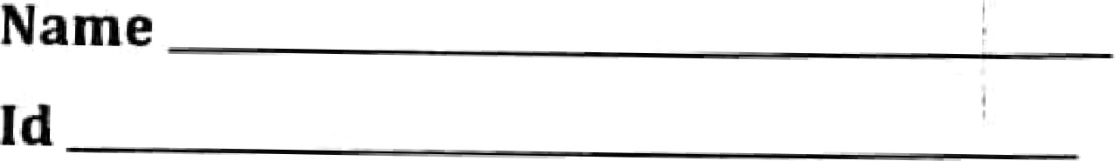

Center

Good Luck!!!!

March, 2023

Collins Computer Time share Company entered into the following transactions during May2017.

1. Purchased computer terminals for $20,000 from Digital Equipment on account
2. Paid $3,000 cash for Mayrenton storage space.

 Received S 14,000 cash from customers for contracts billed in April

1. Performed computer services for Schmidt Construction Company for $2,400 cash,
2. Paid Central Stales Power Co. $1 11000 cash for energy usage in May.

Shareholders invested an additional $32,000 in the business.

(g) Paid Digital Equipment for the terminals purchased In (l) above. (h) Incurred advertising expense for May of $1 , 100 on account.

Instructions: Analyze the above transactions

1. Hercules Poirot began operations as a pnvate Investigator on Januaryl,2017. trial balance columns of thg worksheet for Hercules Potrot, P.I.,SA at March 3 lare as follows.

HERCULES POIROT P I SA

Worksheet

FortheQuarterEndedMarch31, 2011

Trial Balance

Account Titles Dr. Cr.



|  |  |  |  |
| --- | --- | --- | --- |
| Cash |  | 1 1 ,410 |  |
| Accounts Receivable |  | 5,920 |  |
| Supplies |  | I ,250 |  |
| Prepaid Insurance |  | 2,400 |  |
| Equipment |  | 15,000 |  |
| Notes Payable |  |  | 10,000 |
| Accounts Payable |  |  | 7350 |
| Share Capital—Ordinary |  |  | 14,000 |
| Dividends |  | 600 |  |
| Service Revenue |  |  | 10.200 |

Salaries and Wages Expense 2,240

Travel Expense 1.300 Rent Expense I ,200

Miscellaneous Expense

|  |  |
| --- | --- |
| 4 |  |

4 550

Other data:

* + 1. Supplies on hand total €500.
    2. Depreciation is €680 per quarter.

3, Interest accrued on 6-month note payable, issued January I ,€300,  Insurance expires at the rate of €200 per month.

5. Services performed but unbilled at March 31 total €1 ,080.

Instructions

* 1. Enter the trial balance on a worksheet and complete the worksheet.
  2. Prepare an Income statement and a retained earmngs statement for the quarter and a classified statement financial position at March31.
  3. Journalize the adjusting entries from the adjustments columns of the worksheet.
  4. Journalize the closing entnes from the financial statement columns of the worksheet

1. Yin & Yang Video has the following unadjusted trial balance as of January 31,

Yin & Yang Video 

Unadjusted Tia' Balance



Debit Credit

 BAIances Bal alwes

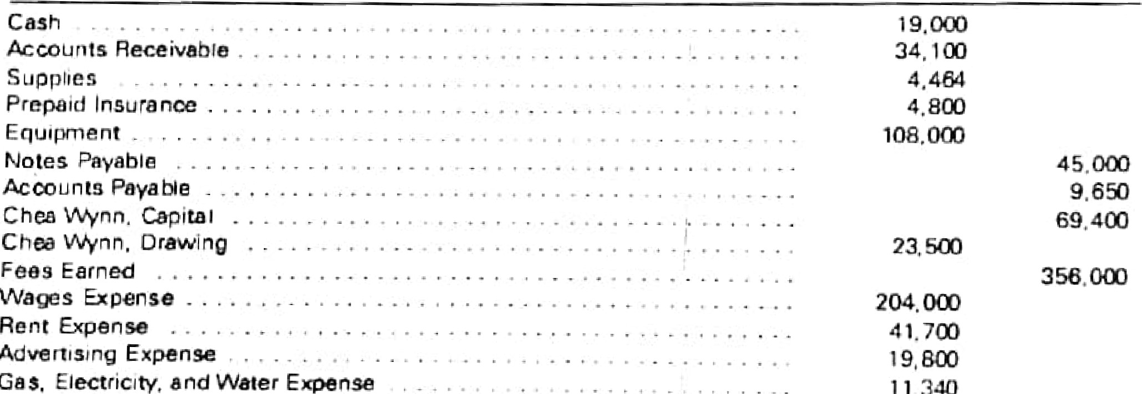

Adverti5tng

11

340

470 or-o The debit and credit totals are not equal as a result of the following errors:

1. The balance of cash was overstated by $10,000,
2. A cash receipt of $6, 100 was posted as a debit to Cash of $1 ,600.
3. A debit of $3,500 to Accounts Receivable was not posted.

d, A return of $415 of defective supplies was erroneously posted as a $451 credit to Supplies.

1. An insurance policy acquired at a cost of $800 was posted as a credit to Prepaid Insurance.
2. The balance of Notes Payable was overstated by $9,000.

g, A credit of $1 ,450 in Accounts Payable was overlooked when the balance of the account was determined.

1. A debit of $2,500 for a withdrawal by the owner was posted as debit to Chea Wynn,

Capital

1. The balance oc $18,900 in Advertising Expense was entered as $19,800 in the trial balance.

 Miscellaneous Expense, With a baluncc of $3,060, was omitted from the trial balance.

Instructions

i. Prepare a corrected unadjusted tnal balance as of January 31 ofthe current year. ii. Does the faci that the unadjusted trual balance in (i) is balanced mean that errors tn the accounts? Explain

4. The followmg transactions were completed by Montrose Company during May of the current year

May 3. Purchased merchandise on account from Floyd Co.. $4,000, terms FOB shipping point. 2/10. n/30, with prepaid Cretght of S 1 20 added to the invoice,

S, Purchased merchandise on account from Kramer Co., $8,500, terms FOB destination. 1/10,

W30



6. Sold merchandise on account to C, F. Howell Co.. list price $4,000, trade discount 30%. terms 2/10, 30. The cost of the merchandise sold was S 1,125 8, Purchased oflice supplucs for cash. S150

10 Returned merchandise purchased on May 5 from Kramer Co.. S 1,300.

13. Paid Floyd Co. on account for purchase of May 3, less discount 14 Purchased merchandiqe for cash, $10,500

IS. Paid Kramer Co, on account for purchase of May 5, less return of May 10 and discount.

16 Received cash on account from sale or May 6 to C. F. Howell Co., less discount.

 19 Sold merchandise on cash, The cost of the merchandise sold was S980.

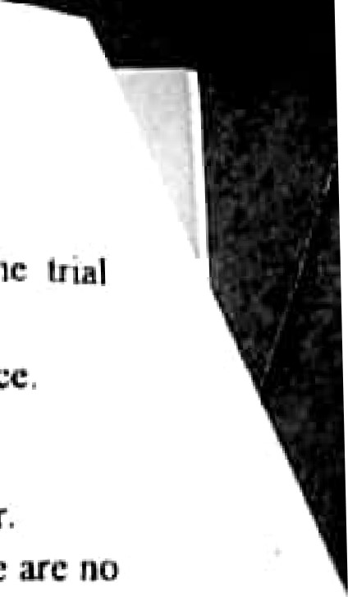

there

22. Sold merchandise on account to Comer Co., $3,480. terms Y 10, nt30. The cost of the merchandi«e sold was S I *400,

1. Sold merchandi«e for cash, S4t3 50. The cost of the merchandise sold was $1,750
2. Recetved merchandise returned by Comer Co. from sale on May 22, SI,480. The cost of the returned merchandise was $600, Instructions

i. Journalize the preceding transacuons assuming that:

* 1. Montrose Company uses * periodic inventory system.
  2. Montrose Company uses a perpetual inventory system.

S. The following information were obtarned from TG Co. recorded at the end of the accounung period (June 30. 2000).

Merchandise inventory June 30, 2000S20.ooo

Purchase450.000

Purchase return and allowance..7,000

Purchase discount.... (2% of cost of goods purchased dunng the period)

Sales585300



Gross profit150.000 Freight-in6.820

Freight-out000

Salary expense10.250

Supplies expense2.500

Rent expense 5,500

Miscellaneous expense



1,750

Assuming Illat there is no sales discount and sulcs return und allowance during the period Instruction: Calculate

Ao Merchandise inventory on July l, 1999, B. Purchase dtycount.

C. Cost of goods sold D Operating income

E, COHt of goods purchased

6, The cash in bank account Cot I).X Co, on May 31 of the current year indicated a bulance of S 13,215.80 aner both the cash receipts journal and the check register for May had been posted. The bank statement indicated a balance of S! 9513 90 on May 31. Companson of the bank statement and the accompanying cancelled checks and memorandunts With the records revealed the following reconciling Itcms

Checks outstanding totaled S 7.070.10.

A deposit of $3,915.20, representing receipts of May 31, had been made too late to appear on the bank statement

C. The bank had collected $3,120 on an Interest bearing note left for collecuon. The face of the note was $3,000

A cheek for $69 returned with the statement had been recorded erroneously in the check register as $96, The check was for payment of nn obligation to YX Coe for the purchase of supplies on account.

E, A check drawn for $42 had been erroneously charged by the bank as S24. Fi Bank service charges for May amounted to $2 1.80. Instructions:

i. Prepare bank reconciliation.

ii, Record the necessary entnes in general journal form.

iii. What is the amount of cash bank that should appear on the balance sheet as of May 31

7. Prepare journal entries ror each of the following. aw Issued a check to establish a petty cash fund of $500.

b. The amount of cash in the petty cash fund is S 120. Issued a check to replenish the fund. based on the following summary of petty cash receipts: office supplies. S300 and miscellaneous administrative expense, $75. Record any missing funds in the cash short and over account.

8. On February 20. 2002„ XY Co. discounted at Abyssinia Bank a note receivable at 16% arising from Nille of merchandise. The note was for Br-100,000, 120 days dated on Dec, 20, 2001 15%. Assume the fiscal period OCX Co. ends on Dec. 31 Instruction:

1. Calculate a bank discount and proceed.
2. Prepare a necegsury journal entry.